**Using BattlEye filter to auto-kick players**

BattleEye provides a straightforward and convenient feature to exclude players (kick them out) based on specific criteria defined in custom filter lists. You may be wondering how to exclude a player who remains inactive for an extended period on the server. Before the release of **patch 1.59** for Arma2OA, it was possible to achieve this task by using the "**commandServer**" instruction directly from the "sqf" code of the mission. However, this method is no longer viable. Fortunately, there is a simple and effective alternative, which involves utilizing BattleEye filters. Here are the steps to follow:

1. Begin by creating a filter, starting with the creation of a text file, for instance, named "**publicVariable.txt**" and save it in the **BattlEye folder** where the mission's "**server.cfg**" file is located: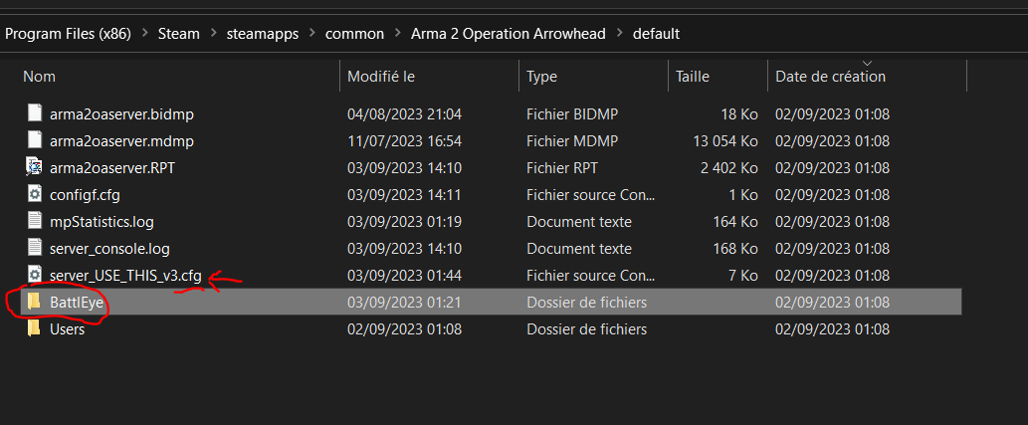

The path may vary, but the procedure remains consistent.

1. In the "**publicVariable.txt**" file, add the line " **5** **kickAFK**", then save it:

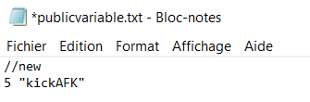

You'll understand why later on.

3. We check for the inactivity condition in one of the "sqf" files of the mission that runs infinitely on the client side (i.e., the player) as long as the player remains connected to the server. When the player stops moving, we then measure the period of inactivity. If this period exceeds a certain threshold, BattleEye proceeds with ejecting the player. To signal this condition to BattleEye, simply add a public variable in the code with the same name as the variable specified in the filter of the previously created text file: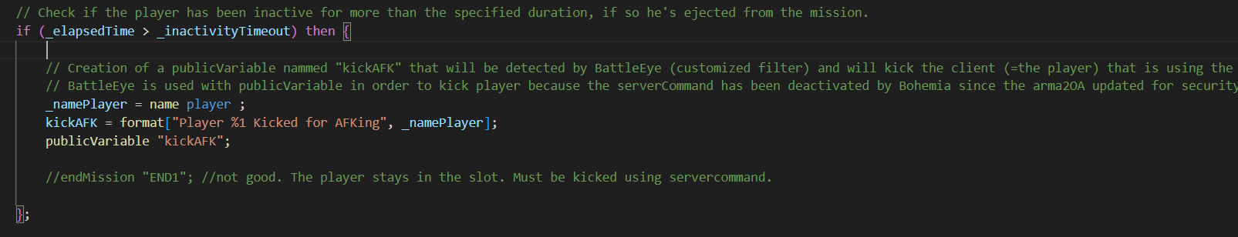

As a result, as soon as this variable is created in the "sqf" code executed on the client side, BattleEye will detect it and automatically eject the relevant client (i.e., the player).

As for measuring the period of inactivity, the complete code is as follows: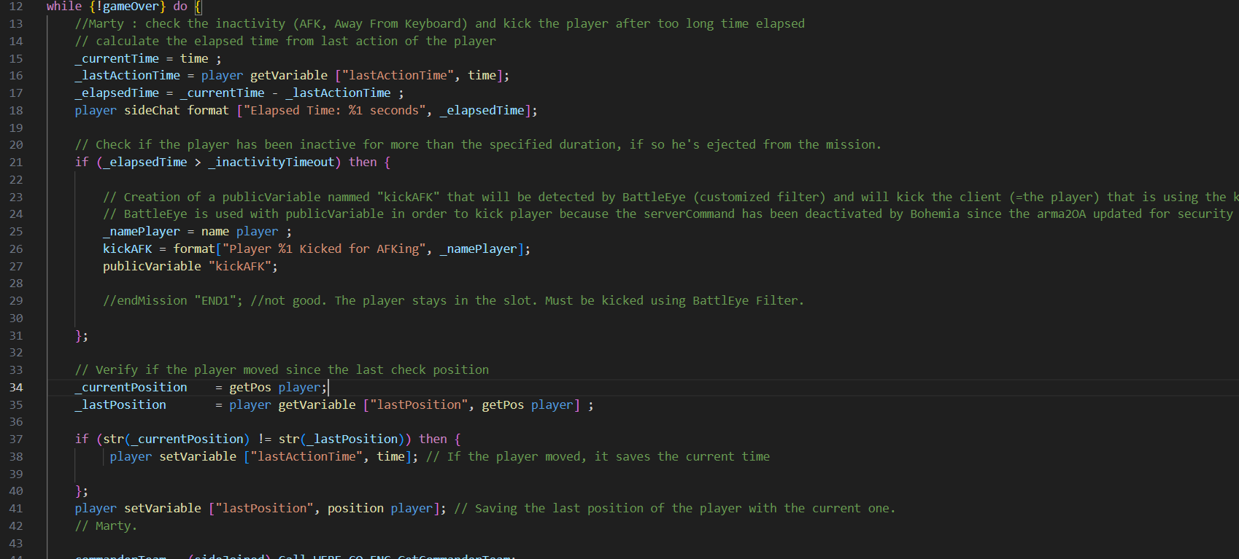

The outcome in testing is as follows when BattleEye ejects the player: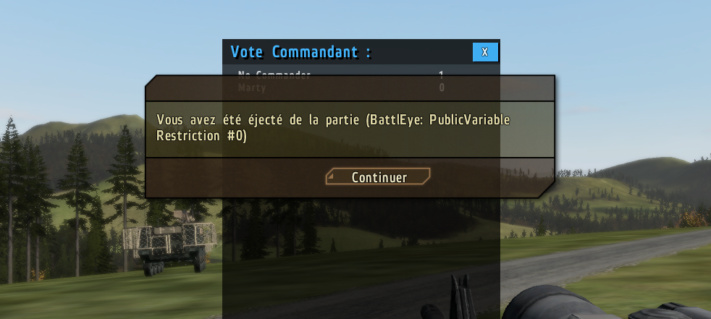

4. Subsequently, you have the option to review the log file automatically generated by BattleEye when an ejection occurs. This file shares the same name as the previously created text file for the filter, but with the ".**log**" extension. It is named "**publicvariable.log**."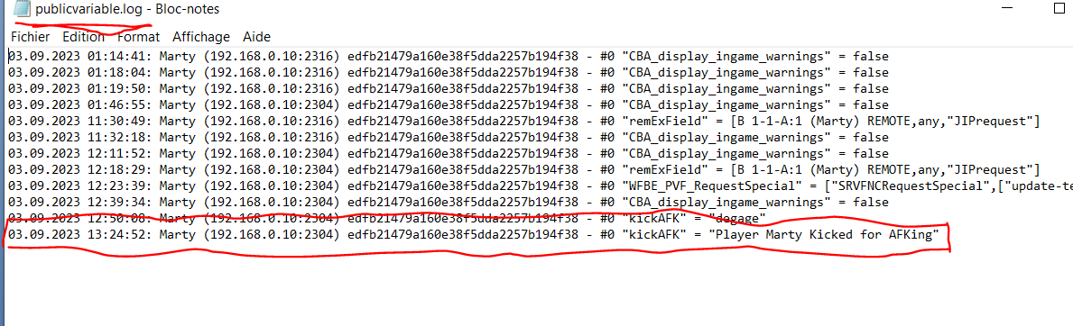

You will find in the log file the date, time, client name, IP address, serial number, the line corresponding to the filter (#0 being the first line of the text file), the name of the public variable, and its value.

A guide on how to use BattleEye filters is also available at the following address:

<https://opendayz.net/threads/a-guide-to-battleye-filters.21066/>